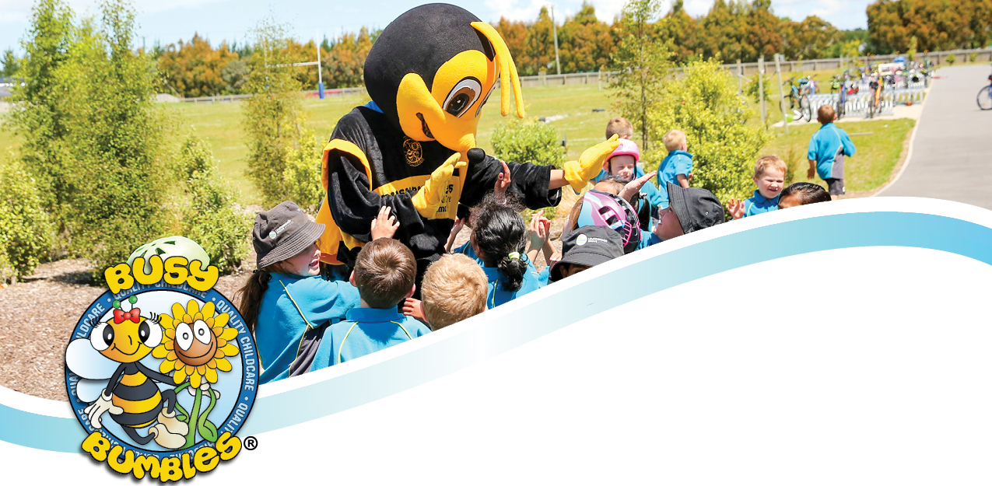
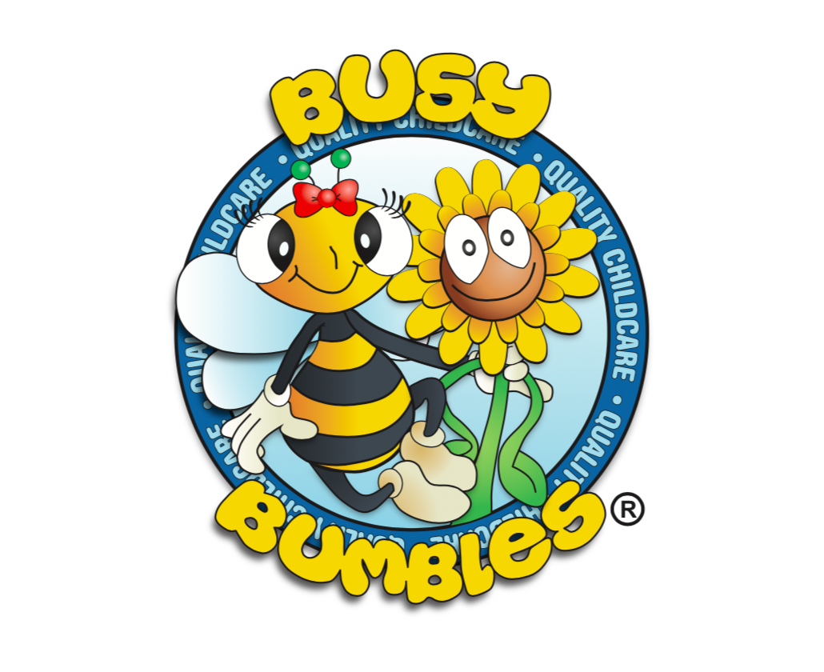

Busy Bumbles Term Planner
Term 1
8 February – 14 April 2022

Detailed weekly planners available to view at each venue.
DATE | WEEK | THEME |  | CRAFT
08/02/22 | 1 | 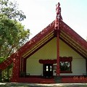 | Waitangi | - Patting bangles  - Design a flag  - Māori cup coasters  - Cloak Collaboration
14/02/22 | 2 |  | Around The World! | - Australian Dot Painting  - Eiffel Tower Straw Art  - Henna Handprints  - Rainbow paper fortune cookies
21/02/22 | 3 |  | Doing good! | - Rubbish Collection  - Washing Vans  - Mystery Notes for Teachers  - Donation bags of toys  - Homemade vouchers
28/02/22 | 4 | 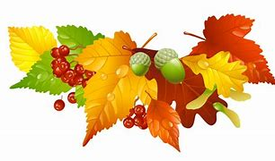 | Autumn Adventure | - 3D Hedgehogs  - Scavenger Hunt  - Handprint Acorns  - Leaf mask  - Leaf Sensory bag
07/03/22 | 5 | 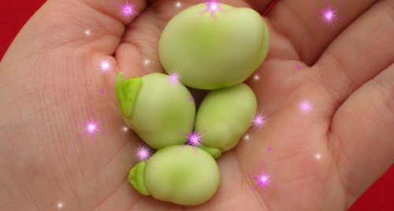 | Fairytale Fantasies | - Gingerbread men  - Fire breathing dragons  - Paper Plate Swan  - Grow your own magic beans!
14/03/22 | 6 |  | Up in the Air we go! | - Design your own paper plane + race!  - Save the egg Parachute activity  - Rocket wand craft  - Plastic bag kites
21/03/22 | 7 |  | Egyptian Era | - Clothes pin camels  - Cartouche  - Egyptian musical statues  - Paper cup pyramid challenge
28/03/22 | 8 |  | BB's got talent! | - Magic trick seminar  - Dancing  - Singing  - Show time!
04/04/22 | 9 |  | Dr Seuss | - Truffle Tree Treats  - Thing 1 and 2 bookmark  - Cat in the Hat  - Lorax picture
11/04/22 | 10 |  | Easter Egg-stravaganza | - Egg Hunt  - Easter bunny baskets  - No sew sock bunnies

DESIGN, DISCOVER, MAKE, MOVE, PLAY

